SECTION 1: IDENTIFICATION
1.1. Product Identifier
Product Form: Mixture
Product Name: Butane Fuel
Product Code: F300, F305

1.2. Intended Use of the Product
Fuel

1.3. Name, Address, and Telephone of the Responsible Party
FancyHeat Corporation
40 Veronica Ave.
Somerset, NJ 08873
(973)-589-1450
www.fancyheat.com
customerservice@fancyheat.com

1.4. Emergency Telephone Number
Emergency Number | : | For Chemical Emergency Call CHEMTREC day or night  Within USA and Canada: 1.800.424.9300  Mexico: 1.800.681.9531  Outside USA and Canada: 1.703.527.3887 (collect calls accepted)
SECTION 2: HAZARDS IDENTIFICATION

2.1. Classification of the Substance or Mixture

GHS-US/CA Classification

Flammable gases Category 1 | H220
Gases under pressure Liquefied gas | H280
Simple Asphyxiant

2.2. Label Elements

GHS-US/CA Labeling
Hazard Pictograms (GHS-US/CA) | : | 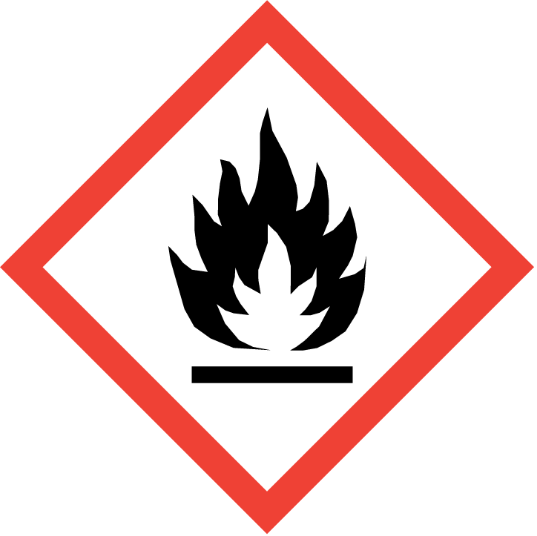  GHS02 | 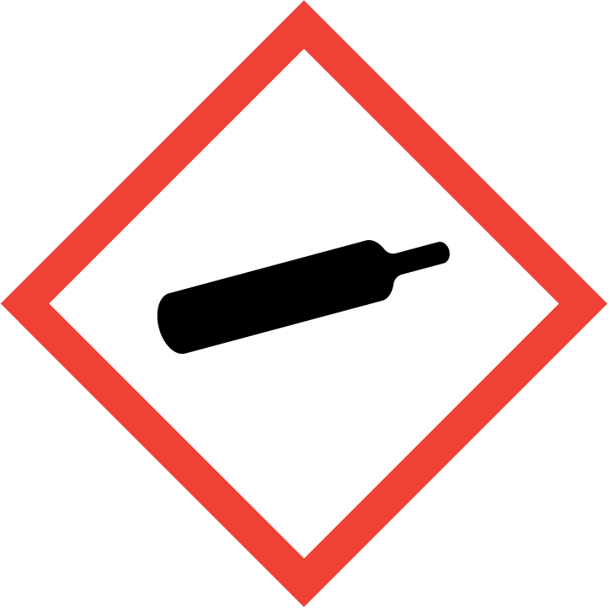  GHS04
Signal Word (GHS-US/CA) | : | Danger
Hazard Statements (GHS-US/CA) | : | H220 - Extremely flammable gas.  H280 - Contains gas under pressure; may explode if heated.  May displace oxygen and cause rapid suffocation.
Precautionary Statements (GHS-US/CA) | : | P210 - Keep away from heat, hot surfaces, sparks, open flames and other ignition sources. No smoking.  P377 - Leaking gas fire: Do not extinguish, unless leak can be stopped safely.  P381 - In case of leakage, eliminate all ignition sources.  P403 - Store in a well-ventilated place.  P410+P403 - Protect from sunlight. Store in a well-ventilated place.

2.3. Other Hazards
Exposure may aggravate pre-existing eye, skin, or respiratory conditions. Contact with gas escaping the container can cause frostbite.

2.4. Unknown Acute Toxicity (GHS-US/CA)
No additional information available

NFPA Health Hazard | : | 2 - Materials that, under emergency conditions, can cause temporary incapacitation or residual injury. | 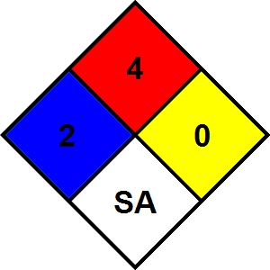
NFPA Fire Hazard | : | 4 - Materials that rapidly or completely vaporize at atmospheric pressure and normal ambient temperature or that are readily dispersed in air and burn readily.
NFPA Reactivity Hazard | : | 0 - Material that in themselves are normally stable, even under fire conditions.
NFPA Specific Hazards | : | SA - This denotes gases which are simple asphyxiants.

HMIS III Rating
Health | : | 2 Moderate Hazard - Temporary or minor injury may occur
Flammability | : | 4 Severe Hazard
Physical | : | 3 Serious Hazard

SECTION 3: COMPOSITION/INFORMATION ON INGREDIENTS

3.1. Substance
Not applicable

3.2. Mixture
Name | Synonyms | Product Identifier | % * | GHS Ingredient Classification
Isobutane | 2-Methylpropane / Propane, 2-methyl- / ISOBUTANE / R600a / isobutane | (CAS-No.) 75-28-5 | 25 – 100 | Flam. Gas 1, H220  Press. Gas (Liq.), H280  Simple Asphy
n-Butane | Butane / BUTANE | (CAS-No.) 106-97-8 | ≤ 80 | Flam. Gas 1, H220  Press. Gas (Liq.), H280  Simple Asphy
Propane | Normal propane / PROPANE / n-Propane / R290 | (CAS-No.) 74-98-6 | ≤ 25 | Flam. Gas 1, H220  Press. Gas (Liq.), H280  Simple Asphy
Full text of H-statements: see section 16
*Percentages are listed in weight by weight percentage (w/w%) for liquid and solid ingredients. Gas ingredients are listed in volume by volume percentage (v/v%). Composition is variable.

SECTION 4: FIRST AID MEASURES
4.1. Description of First-aid Measures
General: Never give anything by mouth to an unconscious person. If you feel unwell, seek medical advice (show the label where possible).
Inhalation: First, take proper precautions to ensure your own safety before attempting rescue (e.g. wear appropriate respiratory protective equipment, use the buddy system), then remove the exposed person to fresh air. Keep at rest in a position comfortable for breathing. Give oxygen or artificial respiration if necessary. Obtain medical attention if breathing difficulty persists.
Skin Contact: Remove contaminated clothing. Drench affected area with water for at least 5 minutes. Obtain medical attention if irritation develops or persists. If frostbite or freezing from exposure to gas/liquid escaping the container occurs: For brief contact with a small amount: Rewarm with body heat. Get immediate medical advice/attention. For extensive contact or a large amount: Immediately call a poison center/doctor and follow their advice. Specific treatment is urgent, incorrect first-aid practices will aggravate the injury. Protect affected area with a loose cover until proper medical treatment is received.
Eye Contact: Rinse cautiously with water for at least 5 minutes. Remove contact lenses, if present and easy to do. Continue rinsing. Obtain medical attention if irritation develops or persists. In case of freeze burn cover eyes to protect from light. Seek immediate medical attention.
Ingestion: Rinse mouth. Do NOT induce vomiting. Obtain medical attention.

4.2. Most Important Symptoms and Effects Both Acute and Delayed
General: Asphyxia by lack of oxygen: risk of death. May cause frostbite on contact with the liquid.

Inhalation: In elevated concentrations may cause asphyxiation, central nervous system effects, and increased breathing rate. Symptoms of asphyxiation include headache, dizziness, rapid breathing, increased pulse, mood changes, tremors, cyanosis, muscular weakness, narcosis, numbness of the extremities, unconsciousness and death.
Skin Contact: Contact with gas/liquid escaping the container can cause frostbite and freeze burns.
Eye Contact: Contact with gas/liquid escaping the container can cause frostbite, freeze burns, and permanent eye damage.
Ingestion: Not considered a potential route of exposure, but contact with gas/liquid escaping the container can cause freeze burns and frostbite.
Chronic Symptoms: None expected under normal conditions of use.

4.3. Indication of Any Immediate Medical Attention and Special Treatment Needed
If exposed or concerned, get medical advice and attention. If medical advice is needed, have product container or label at hand.
SECTION 5: FIRE-FIGHTING MEASURES

5.1. Extinguishing Media
Suitable Extinguishing Media: Do not extinguish burning gas if flow cannot be shut off immediately. Extinguish secondary FIRES with appropriate materials.
Unsuitable Extinguishing Media: Do not use a heavy water stream. Use of heavy stream of water may spread fire.

5.2. Special Hazards Arising From the Substance or Mixture
Fire Hazard: Extremely flammable gas.
Explosion Hazard: May form flammable/explosive vapor-air mixture. Container may explode in heat of fire.
Reactivity: Hazardous reactions will not occur under normal conditions.

5.3. Advice for Firefighters
Precautionary Measures Fire: Exercise caution when fighting any chemical fire.
Firefighting Instructions: Fight fire remotely due to the risk of explosion. Leaking gas fire: Do not extinguish, unless leak can be stopped safely. Eliminate all ignition sources if safe to do so. Use water spray or fog for cooling exposed containers.
Protection During Firefighting: Do not enter fire area without proper protective equipment, including respiratory protection.
Hazardous Combustion Products: Carbon oxides (CO, CO₂).
Other Information: Use water spray to disperse vapors.

5.4. Reference to Other Sections
Refer to Section 9 for flammability properties.

SECTION 6: ACCIDENTAL RELEASE MEASURES

6.1. Personal Precautions, Protective Equipment and Emergency Procedures
General Measures: Eliminate every possible source of ignition. Do not get in eyes, on skin, or on clothing. Do not breathe Gas.

6.1.1. For Non-Emergency Personnel
Protective Equipment: Use appropriate personal protective equipment (PPE).
Emergency Procedures: Evacuate unnecessary personnel.
6.1.2. For Emergency Personnel
Protective Equipment: Equip cleanup crew with proper protection.
Emergency Procedures: Eliminate ignition sources first, then evacuate unnecessary personnel, isolate, and ventilate area. Upon arrival at the scene, a first responder is expected to recognize the presence of dangerous goods, protect oneself and the public, secure the area, and call for the assistance of trained personnel as soon as conditions permit.

6.2. Environmental Precautions
Prevent entry to sewers and public waters.

6.3. Methods and Materials for Containment and Cleaning Up
For Containment: As an immediate precautionary measure, isolate spill or leak area in all directions. Stop leak, if possible without risk.
Methods for Cleaning Up: Clean up spills immediately and dispose of waste safely. Stop the source of the release, if safe to do so. Consider the use of water spray to disperse vapors. Isolate the area until gas has dispersed. Ventilate and gas test area before entering. Contact competent authorities after a spill.

6.4. Reference to Other Sections
See Section 8 for exposure controls and personal protection and Section 13 for disposal considerations.

SECTION 7: HANDLING AND STORAGE

7.1. Precautions for Safe Handling
Additional Hazards When Processed: Do not pressurize, cut, or weld containers. Ruptured cylinders may rocket. Asphyxiating gas at high concentrations. Handle empty containers with care because residual vapors are flammable.
Precautions for Safe Handling: Do not breathe gas. Avoid prolonged contact with eyes, skin and clothing. Wash hands and other exposed areas with mild soap and water before eating, drinking or smoking and when leaving work.
Hygiene Measures: Handle in accordance with good industrial hygiene and safety procedures.
7.2. Conditions for Safe Storage, Including Any Incompatibilities
Technical Measures: Proper grounding procedures to avoid static electricity should be followed. Comply with applicable regulations.
Storage Conditions: Cylinders should be stored upright with valve protection cap in place and firmly secured to prevent falling. Keep container closed when not in use. Store in a dry, cool place. Keep/Store away from direct sunlight, extremely high or low temperatures and incompatible materials. Keep in fireproof place.
Incompatible Materials: Strong acids, strong bases, strong oxidizers. Halogenated compounds.

7.3. Specific End Use(s)
Fuel

SECTION 8: EXPOSURE CONTROLS/PERSONAL PROTECTION

8.1. Control Parameters

For substances listed in section 3 that are not listed here, there are no established exposure limits from the manufacturer, supplier, importer, or the appropriate advisory agency including: ACGIH (TLV), AIHA (WEEL), NIOSH (REL), OSHA (PEL), or Canadian provincial governments.

Propane (74-98-6)
USA ACGIH | ACGIH chemical category | Simple asphyxiant See Appendix F: Minimal Oxygen Content
USA OSHA | OSHA PEL (TWA) [1] | 1800 mg/m³
USA OSHA | OSHA PEL (TWA) [2] | 1000 ppm
USA NIOSH | NIOSH REL (TWA) | 1800 mg/m³
USA NIOSH | NIOSH REL TWA [ppm] | 1000 ppm
USA IDLH | IDLH [ppm] | 2100 ppm (10% LEL)
Alberta | OEL TWA [ppm] | 1000 ppm
Nunavut | OEL STEL [ppm] | 1250 ppm
Nunavut | OEL TWA [ppm] | 1000 ppm
Northwest Territories | OEL STEL [ppm] | 1250 ppm
Northwest Territories | OEL TWA [ppm] | 1000 ppm
Québec | VEMP (OEL TWA) | 1800 mg/m³
Québec | VEMP (OEL TWA) [ppm] | 1000 ppm
Saskatchewan | OEL STEL [ppm] | 1250 ppm
Saskatchewan | OEL TWA [ppm] | 1000 ppm

Isobutane (75-28-5)
USA ACGIH | ACGIH OEL STEL [ppm] | 1000 ppm (explosion hazard (Butane, isomers)
USA NIOSH | NIOSH REL (TWA) | 1900 mg/m³
USA NIOSH | NIOSH REL TWA [ppm] | 800 ppm
British Columbia | OEL STEL [ppm] | 1000 ppm (Butane, all isomers)
Manitoba | OEL STEL [ppm] | 1000 ppm (explosion hazard (Butane, isomers)
Newfoundland & Labrador | OEL STEL [ppm] | 1000 ppm (explosion hazard (Butane, isomers)
Nova Scotia | OEL STEL [ppm] | 1000 ppm (explosion hazard (Butane, isomers)
Nunavut | OEL STEL [ppm] | 1250 ppm (Butane, all isomers)
Nunavut | OEL TWA [ppm] | 1000 ppm (Butane, all isomers)
Northwest Territories | OEL STEL [ppm] | 1250 ppm (Butane, all isomers)
Northwest Territories | OEL TWA [ppm] | 1000 ppm (Butane, all isomers)
Ontario | OEL STEL [ppm] | 1000 ppm (explosion hazard (Butane, all isomers)
Prince Edward Island | OEL STEL [ppm] | 1000 ppm (explosion hazard (Butane, isomers)
Saskatchewan | OEL STEL [ppm] | 1250 ppm (Butane, all isomers)
Saskatchewan | OEL TWA [ppm] | 1000 ppm (Butane, all isomers)

n-Butane (106-97-8)
USA ACGIH | ACGIH OEL STEL [ppm] | 1000 ppm (explosion hazard (Butane, isomers)
USA NIOSH | NIOSH REL (TWA) | 1900 mg/m³
USA NIOSH | NIOSH REL TWA [ppm] | 800 ppm
USA IDLH | IDLH [ppm] | 1600 ppm (>10% LEL)
Alberta | OEL TWA [ppm] | 1000 ppm
British Columbia | OEL STEL [ppm] | 1000 ppm (Butane, all isomers)
Manitoba | OEL STEL [ppm] | 1000 ppm (explosion hazard (Butane, isomers)
New Brunswick | OEL TWA | 1900 mg/m³
New Brunswick | OEL TWA [ppm] | 800 ppm
Newfoundland & Labrador | OEL STEL [ppm] | 1000 ppm (explosion hazard (Butane, isomers)
Nova Scotia | OEL STEL [ppm] | 1000 ppm (explosion hazard (Butane, isomers)
Nunavut | OEL STEL [ppm] | 1250 ppm (Butane, all isomers)
Nunavut | OEL TWA [ppm] | 1000 ppm (Butane, all isomers)
Northwest Territories | OEL STEL [ppm] | 1250 ppm (Butane, all isomers)
Northwest Territories | OEL TWA [ppm] | 1000 ppm (Butane, all isomers)
Ontario | OEL STEL [ppm] | 1000 ppm (explosion hazard (Butane, all isomers)
Prince Edward Island | OEL STEL [ppm] | 1000 ppm (explosion hazard (Butane, isomers)
Québec | VEMP (OEL TWA) | 1900 mg/m³
Québec | VEMP (OEL TWA) [ppm] | 800 ppm
Saskatchewan | OEL STEL [ppm] | 1250 ppm (Butane, all isomers)
Saskatchewan | OEL TWA [ppm] | 1000 ppm (Butane, all isomers)
Yukon | OEL STEL | 1600 mg/m³
Yukon | OEL STEL [ppm] | 750 ppm
Yukon | OEL TWA | 1400 mg/m³
Yukon | OEL TWA [ppm] | 600 ppm

Aliphatic hydrocarbon gases: Alkanes (C1-4)
Nunavut | OEL STEL [ppm] | 1250 ppm
Nunavut | OEL TWA [ppm] | 1000 ppm
Northwest Territories | OEL STEL [ppm] | 1250 ppm
Northwest Territories | OEL TWA [ppm] | 1000 ppm
Saskatchewan | OEL STEL [ppm] | 1250 ppm
Saskatchewan | OEL TWA [ppm] | 1000 ppm

Aliphatic hydrocarbon gases, alkane (C2-4)
Alberta | OEL TWA [ppm] | 1000 ppm

8.2. Exposure Controls
Appropriate Engineering Controls: Ensure adequate ventilation, especially in confined areas. Use explosion-proof equipment. Proper grounding procedures to avoid static electricity should be followed. Gas detectors should be used when flammable gases or vapors may be released. Oxygen detectors should be used when asphixiating gases may be released. Suitable eye/body wash equipment should be available in the vicinity of any potential exposure. Ensure all national/local regulations are observed.
Personal Protective Equipment: Gloves. Protective clothing. Protective goggles. Insufficient ventilation: wear respiratory protection. Respiratory protection of the dependent type.
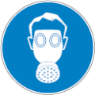
Materials for Protective Clothing: Chemically resistant materials and fabrics. Wear fire/flame resistant/retardant clothing.
Hand Protection: Wear protective gloves. If material is cold, wear thermally resistant protective gloves.
Eye and Face Protection: Chemical safety goggles.
Skin and Body Protection: Wear suitable protective clothing.
Respiratory Protection: Use a NIOSH-approved self-contained breathing apparatus whenever exposure may exceed established Occupational Exposure Limits.
Thermal Hazard Protection: Wear thermally resistant protective clothing.
Other Information: When using, do not eat, drink or smoke.

SECTION 9: PHYSICAL AND CHEMICAL PROPERTIES
9.1. Information on Basic Physical and Chemical Properties
Physical State | : | Gas
Appearance | : | Colorless
Odor | : | Characteristic
Odor Threshold | : | No data available
pH | : | No data available
Evaporation Rate | : | No data available
Melting Point | : | No data available
Freezing Point | : | No data available
Boiling Point | : | -44 °C (-47.2 °F)
Flash Point | : | -1 °C (30.2 °F)
Auto-ignition Temperature | : | 460 °C (860 °F)
Decomposition Temperature | : | No data available
Flammability (solid, gas) | : | Extremely flammable gas
Lower Flammable Limit | : | 1.7 %
Upper Flammable Limit | : | 10.9 %
Vapor Pressure | : | 8300 hPa at 20 °C (68 °F)
Relative Vapor Density at 20°C | : | No data available
Relative Density | : | No data available
Density | : | 0.4 g/cm³ at 20 °C (3.338 lbs/gal at 68 °F)
Specific Gravity | : | No data available
Solubility | : | No data available
Partition Coefficient: N-Octanol/Water | : | No data available
Viscosity | : | No data available
Explosive Properties | : | Contains gas under pressure; may explode if heated

SECTION 10: STABILITY AND REACTIVITY
10.1. Reactivity:
Hazardous reactions will not occur under normal conditions.
10.2. Chemical Stability:
Contains gas under pressure; may explode if heated.
10.3. Possibility of Hazardous Reactions:
Hazardous polymerization will not occur.
10.4. Conditions to Avoid:
Direct sunlight, extremely high or low temperatures, open flames, sources of ignition and incompatible materials.
10.5. Incompatible Materials:
Strong acids, strong bases, strong oxidizers. Halogenated compounds.
10.6. Hazardous Decomposition Products:
Thermal decomposition may produce: Carbon oxides (CO, CO₂).
SECTION 11: TOXICOLOGICAL INFORMATION
11.1. Information on Toxicological Effects - Product
Acute Toxicity (Oral): Not classified
Acute Toxicity (Dermal): Not classified
Acute Toxicity (Inhalation): Not classified
LD50 and LC50 Data:
No additional information available
Skin Corrosion/Irritation: Not classified
Eye Damage/Irritation: Not classified
Respiratory or Skin Sensitization: Not classified
Germ Cell Mutagenicity: Not classified
Carcinogenicity: Not classified
Specific Target Organ Toxicity (Repeated Exposure): Not classified
Reproductive Toxicity: Not classified
Specific Target Organ Toxicity (Single Exposure): Not classified
Aspiration Hazard: Not classified
Symptoms/Injuries After Inhalation: In elevated concentrations may cause asphyxiation, central nervous system effects, and increased breathing rate. Symptoms of asphyxiation include headache, dizziness, rapid breathing, increased pulse, mood changes, tremors, cyanosis, muscular weakness, narcosis, numbness of the extremities, unconsciousness and death.
Symptoms/Injuries After Skin Contact: Contact with gas/liquid escaping the container can cause frostbite and freeze burns.
Symptoms/Injuries After Eye Contact: Contact with gas/liquid escaping the container can cause frostbite, freeze burns, and permanent eye damage.
Symptoms/Injuries After Ingestion: Not considered a potential route of exposure, but contact with gas/liquid escaping the container can cause freeze burns and frostbite.
Chronic Symptoms: None expected under normal conditions of use.

11.2. Information on Toxicological Effects - Ingredient(s)
LD50 and LC50 Data:
Propane (74-98-6)
LC50 Inhalation Rat | > 800000 ppm (Exposure time: 15 min)

n-Butane (106-97-8)
LC50 Inhalation Rat | 30957 mg/m³ (Exposure time: 4 h)
LC50 Inhalation Rat | 276798.8 ppm

SECTION 12: ECOLOGICAL INFORMATION

12.1. Toxicity
Ecology - General: Not classified.

12.2. Persistence and Degradability
Butane Fuel
Persistence and Degradability | Not established.

12.3. Bioaccumulative Potential
Butane Fuel
Bioaccumulative Potential | Not established.

Propane (74-98-6)
Partition coefficient n-octanol/water (Log Pow) | 1.09 at 20 °C (at pH 7)

Isobutane (75-28-5)
BCF Fish 1 | 1.57 – 1.97
Partition coefficient n-octanol/water (Log Pow) | 1.09 – 2.8 at 20 °C (at pH 7)

n-Butane (106-97-8)
Partition coefficient n-octanol/water (Log Pow) | 2.31 at 20 °C (at pH 7)

12.4. Mobility in Soil
No additional information available
12.5. Other Adverse Effects
Other Information: Avoid release to the environment.
SECTION 13: DISPOSAL CONSIDERATIONS
13.1. Waste treatment methods
Waste Disposal Recommendations: Dispose of contents/container in accordance with local, regional, national, territorial, provincial, and international regulations.
Additional Information: Handle empty containers with care because residual vapors are flammable. Empty gas cylinders should be returned to the vendor for recycling or refilling. Do not puncture or incinerate container.
Ecology - Waste Materials: Avoid release to the environment.

SECTION 14: TRANSPORT INFORMATION
The shipping description(s) stated herein were prepared in accordance with certain assumptions at the time the SDS was authored, and can vary based on a number of variables that may or may not have been known at the time the SDS was issued.
14.1. In Accordance with DOT
Proper Shipping Name | : | RECEPTACLES, SMALL, CONTAINING GAS
Hazard Class | : | 2.1 | 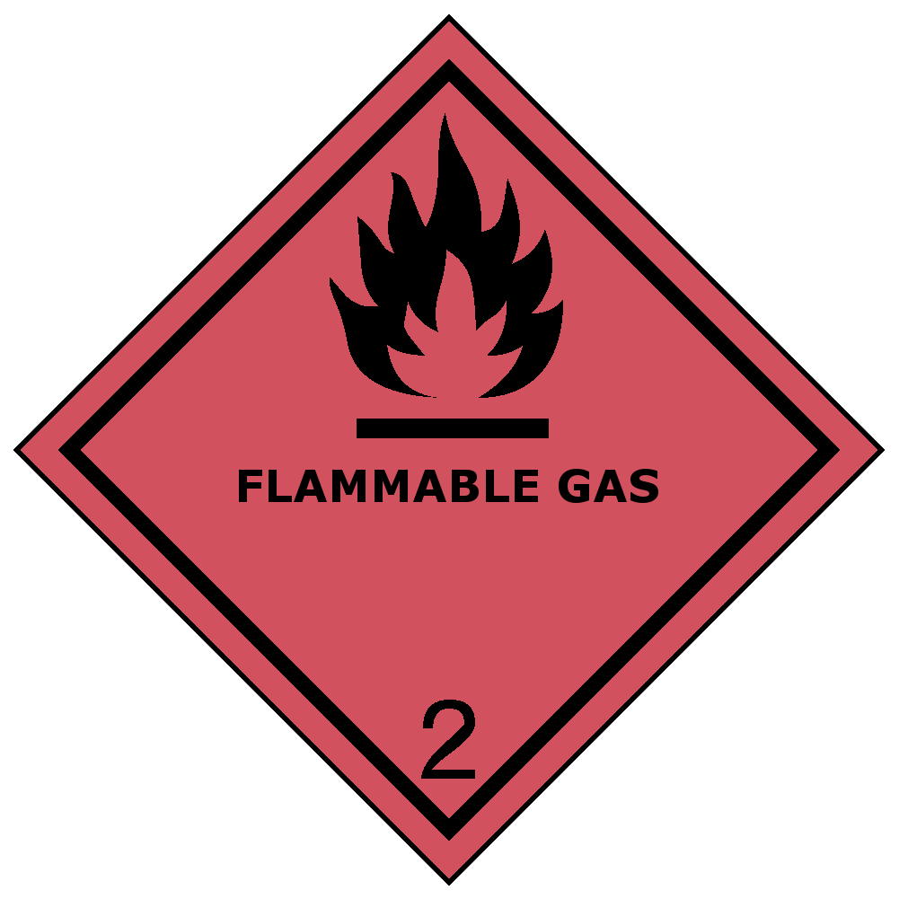
Identification Number | : | UN2037
Label Codes | : | 2.1
ERG Number | : | 115
14.2. In Accordance with IMDG
Proper Shipping Name | : | RECEPTACLES, SMALL, CONTAINING GAS (GAS CARTRIDGES)
Hazard Class | : | 2.1 | 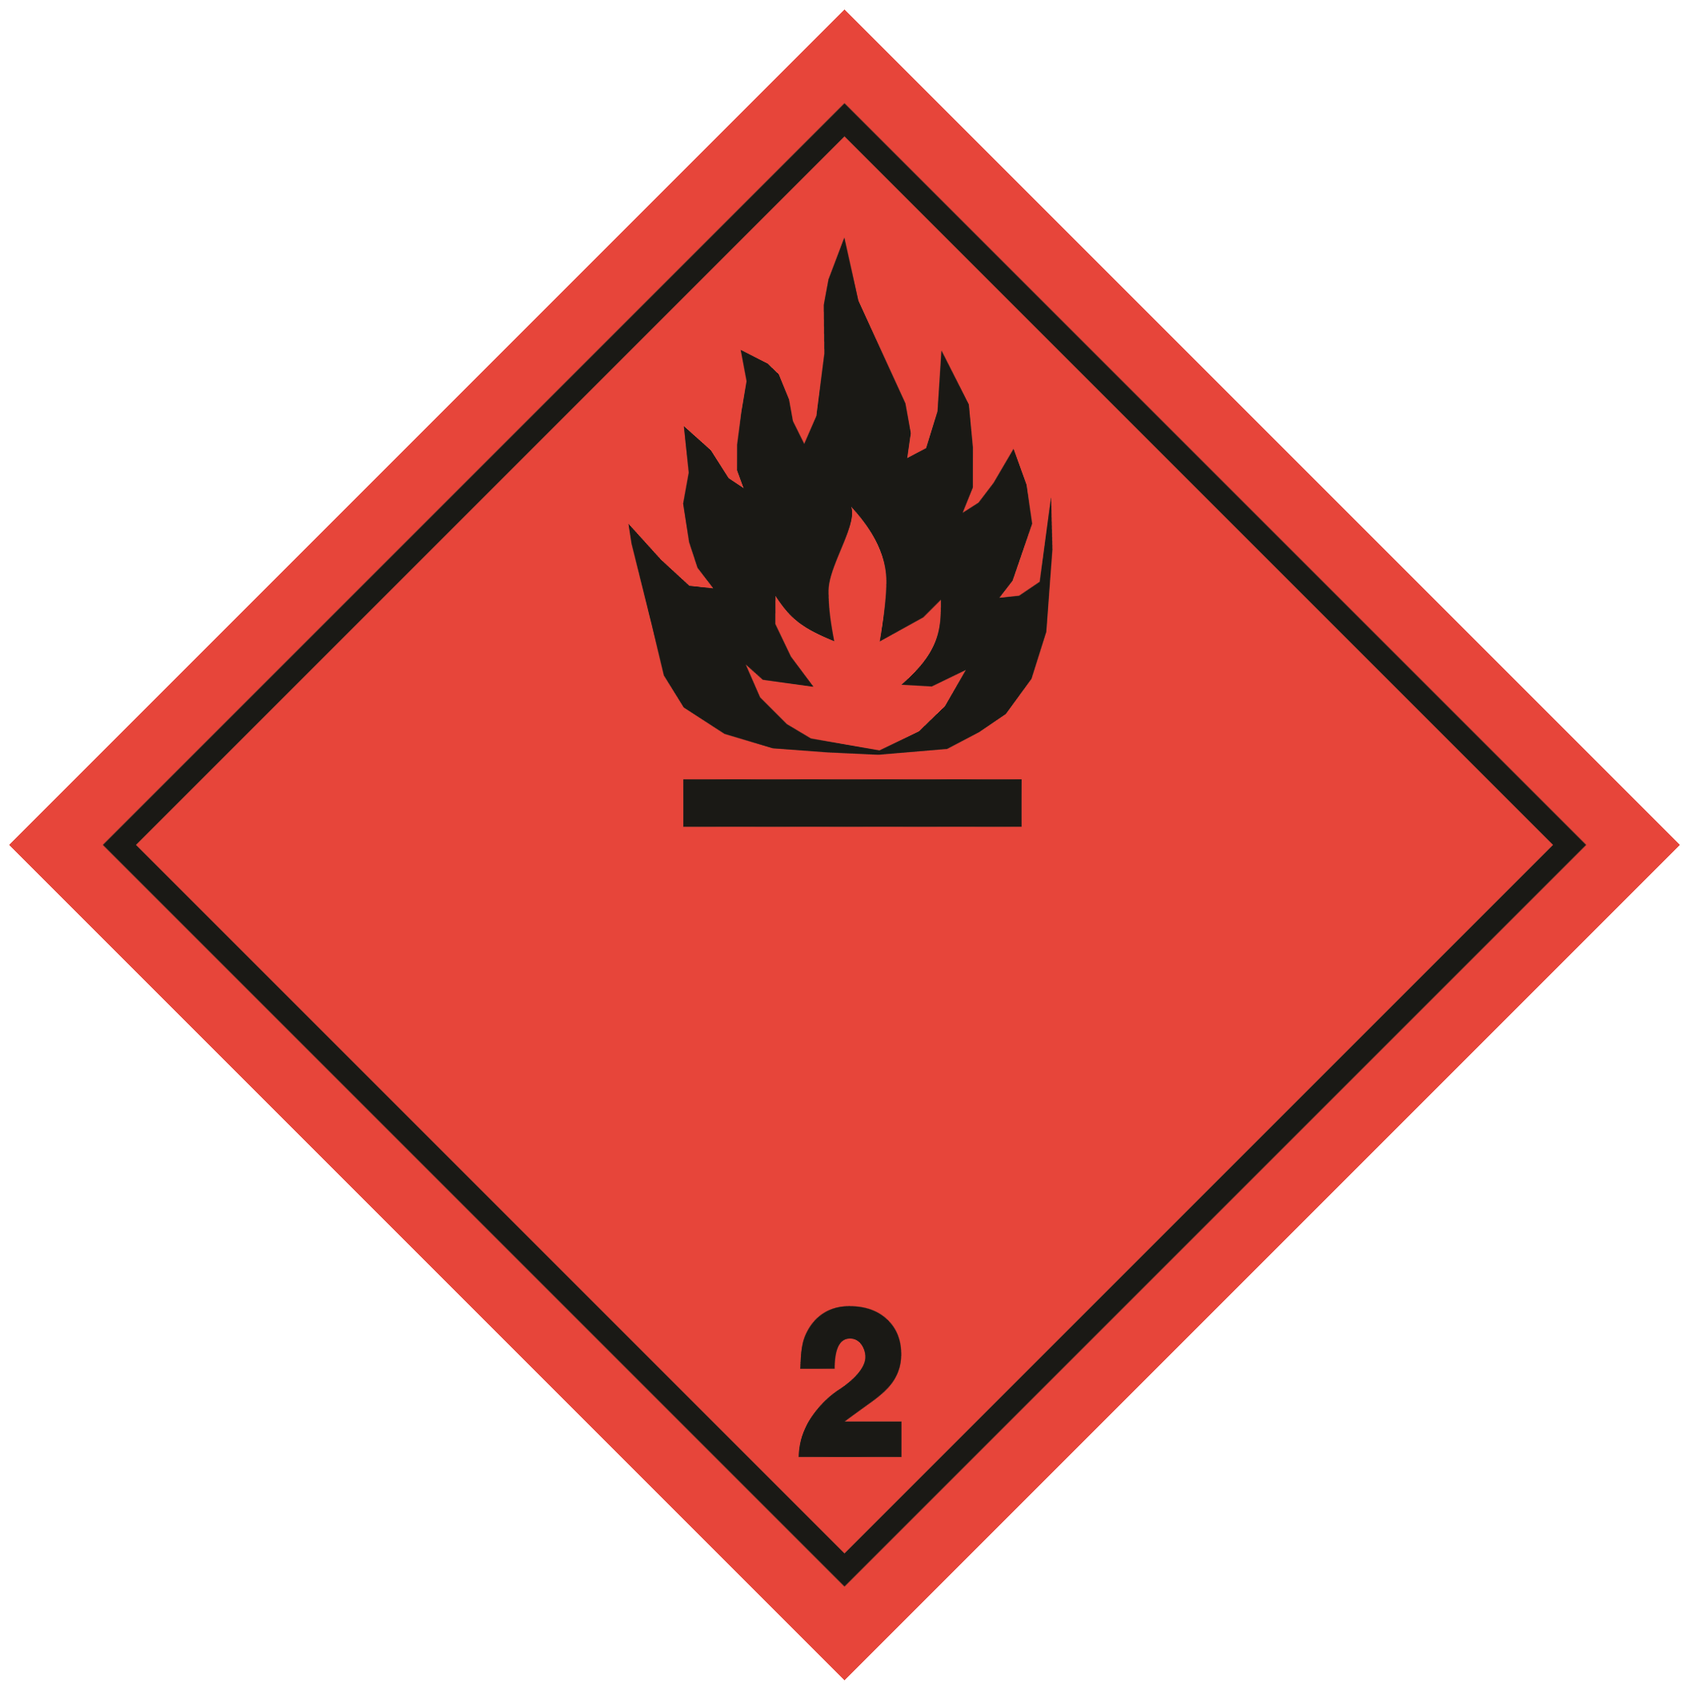
Identification Number | : | UN2037
Label Codes | : | 2.1
EmS-No. (Fire) | : | F-D
EmS-No. (Spillage) | : | S-U
14.3. In Accordance with IATA
Proper Shipping Name | : | RECEPTACLES, SMALL, CONTAINING GAS
Hazard Class | : | 2.1 | 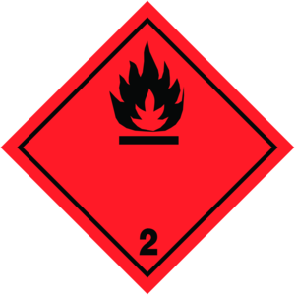
Identification Number | : | UN2037
Label Codes | : | 2.1
ERG Code (IATA) | : | 10L
14.4. In Accordance with TDG
Proper Shipping Name | : | RECEPTACLES, SMALL, CONTAINING GAS
Hazard Class | : | 2.1
Identification Number | : | UN2037
Label Codes | : | 2.1
SECTION 15: REGULATORY INFORMATION

15.1. US Federal Regulations
Butane Fuel
SARA Section 311/312 Hazard Classes | Physical hazard - Flammable (gases, aerosols, liquids, or solids)  Physical hazard - Gas under pressure  Health hazard - Simple asphyxiant

Propane (74-98-6)
Listed on the United States TSCA (Toxic Substances Control Act) inventory - Status: Active

Isobutane (75-28-5)
Listed on the United States TSCA (Toxic Substances Control Act) inventory - Status: Active

n-Butane (106-97-8)
Listed on the United States TSCA (Toxic Substances Control Act) inventory - Status: Active

15.2. US State Regulations

Propane (74-98-6)
U.S. - New Jersey - Right to Know Hazardous Substance List
U.S. - Pennsylvania - RTK (Right to Know) List
U.S. - Massachusetts - Right To Know List

Isobutane (75-28-5)
U.S. - New Jersey - Right to Know Hazardous Substance List
U.S. - Pennsylvania - RTK (Right to Know) List
U.S. - Massachusetts - Right To Know List

n-Butane (106-97-8)
U.S. - New Jersey - Right to Know Hazardous Substance List
U.S. - Pennsylvania - RTK (Right to Know) List
U.S. - Massachusetts - Right To Know List

15.3. Canadian Regulations

Propane (74-98-6)
Listed on the Canadian DSL (Domestic Substances List)

Isobutane (75-28-5)
Listed on the Canadian DSL (Domestic Substances List)

n-Butane (106-97-8)
Listed on the Canadian DSL (Domestic Substances List)

SECTION 16: OTHER INFORMATION, INCLUDING DATE OF PREPARATION OR LAST REVISION

Date of Preparation or Latest Revision | : | 06/20/2023
Other Information | : | This document has been prepared in accordance with the SDS requirements of the OSHA Hazard Communication Standard 29 CFR 1910.1200 and Canada’s Hazardous Products Regulations (HPR) SOR/2015-17.
GHS Full Text Phrases:

------ | H220 | Extremely flammable gas
------ | H280 | Contains gas under pressure; may explode if heated

This information is based on our current knowledge and is intended to describe the product for the purposes of health, safety and environmental requirements only. It should not therefore be construed as guaranteeing any specific property of the product.

NA GHS SDS 2015 (Can, US)

